**BAIT 507 HW Assignment 2**

**Data Ethics**

|  |  |  |  |
| --- | --- | --- | --- |
| **Team Members (BA1)** | | | |
| **#** | **Name** | **Student ID** | **Email** |
| 1 | Zhi (Krystal) Li | 95680609 | zhili01@student.ubc.ca |
| 2 | Yousef Jafarnia | 37746765 | Yousef.jafarnia@gmail.com |
| 3 | Pranav Mehta | 19184282 | pranavmehta98@gmail.com |
| 4 | Vineet Menon | 90744863 | mvineet@student.ubc.ca |

**Q1: Do you see a risk for the CCI rewards to bias against customers with a specific profile?**

**Answer:** We analyzed parameters like location, income level, age groups of users by ratio of credit redeemed to credit earned. Observations as follows:

There seems to be an inherent bias based on locations, classified at “city” level. Based on the urbanization levels, it can be presumed that app users in cities like Changsha (which are not as urbanized as the other cities in the list), have lesser redemption ratio of credits. Based on income levels, it appears that the rewards program appeals more to users classified having “low income”. In order to observe biases by age, the users were grouped into 3 brackets (<25, 25 – 50, >50). The rewards utilization is evident only in the middle age range. Queries & outputs below:

* **Query for Analysis based on Address - Cities**

select earnedanalysis.ucity, round("total used credit"/"total earned credit",2) as "credit usage ratio"

from

(select ucity, sum(claimedrewardamount*requiredcreditamount) as "total used credit"

from

cciuser left join rewardclaim

on cciuser.userid = rewardclaim.userid

left join carbonreward

on rewardclaim.rewardid = carbonreward.rewardid

group by ucity) claimedanalysis

right join

(select ucity, sum(creditearned*participationamount) as "total earned credit"

from

cciuser left join participation

on cciuser.userid =participation.userid

left join activity

on participation.activityid = activity.activityid

group by ucity) earnedanalysis

on claimedanalysis.ucity = earnedanalysis.ucity

;

* + **Output:**

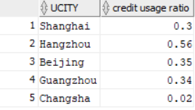

* **Query for analysis based on income levels**

select earnedanalysis.income, round("total used credit"/"total earned credit",2) as "credit usage ratio"

from

(select income, sum(claimedrewardamount*requiredcreditamount) as "total used credit"

from

cciuser left join rewardclaim

on cciuser.userid = rewardclaim.userid

left join carbonreward

on rewardclaim.rewardid = carbonreward.rewardid

group by income) claimedanalysis

right join

(select income, sum(creditearned*participationamount) as "total earned credit"

from

cciuser left join participation

on cciuser.userid =participation.userid

left join activity

on participation.activityid = activity.activityid

group by income) earnedanalysis

on claimedanalysis.income = earnedanalysis.income

;

* + **Output:**

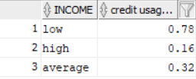

* **Query for analyzing by age range**

select

case

when TRUNC(MONTHS_BETWEEN(SYSDATE, earnedanalysis.birthday) / 12) < 25 then 'low age'

when TRUNC(MONTHS_BETWEEN(SYSDATE, earnedanalysis.birthday) / 12) < 50 then 'mid age'

else 'high age'

end as "age range"

,round(avg(COALESCE(("total used credit"/"total earned credit"),0)),2) as "credit usage ratio"

from

(select birthday, sum(claimedrewardamount*requiredcreditamount) as "total used credit"

from

cciuser left join rewardclaim

on cciuser.userid = rewardclaim.userid

left join carbonreward

on rewardclaim.rewardid = carbonreward.rewardid

group by birthday) claimedanalysis

right join

(select birthday, sum(creditearned*participationamount) as "total earned credit"

from

cciuser left join participation

on cciuser.userid =participation.userid

left join activity

on participation.activityid = activity.activityid

group by birthday) earnedanalysis

on claimedanalysis.birthday = earnedanalysis.birthday

group by

case

when TRUNC(MONTHS_BETWEEN(SYSDATE, earnedanalysis.birthday) / 12) < 25 then 'low age'

when TRUNC(MONTHS_BETWEEN(SYSDATE, earnedanalysis.birthday) / 12) < 50 then 'mid age'

else 'high age'

end

;

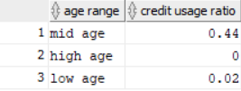

**Q2: Do you see a potential for the CCI rewards to unintendedly increase carbon emissions**

**Answer:**

To understand this, we queried the frequency of the rewards description. A majority of the redemptions were used to “make donations for the forest protection program”. However, other rewards like bottled water and coffee mugs do have a carbon footprint and can increase carbon emission. Also, online shopping discounts at Taobao.com and Tmall.com may also be used to purchase carbon emitting products. These rewards have been redeemed, implying that the reward for the participation does have the (moderately) unintended consequence of increased carbon emissions.

* **Query:**

select rdescription, COALESCE(sum(claimedrewardamount),0) as "total freq"

from

rewardclaim right join carbonreward

on rewardclaim.rewardid = carbonreward.rewardid

group by rdescription

order by "total freq" desc

;

* **Output**

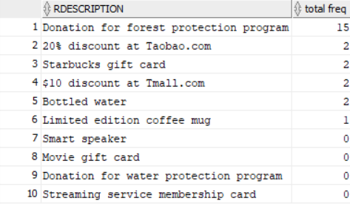

**Q3: Choose one of the ethics issues above and recommend changes in the CCI program that help to remedy it.**

**Answer:**

For ethics issues regarding bias against customers of specific profiles, the following can be considered:

* Target the “younger age” bracket customers with appealing rewards like video game coupons, concert tickets etc.
* For rewards that are more appealing to smaller towns and rural areas, the starbucks coupons, online shopping coupons etc could be replaced by local specialty vouchers, or promotion of renowned local culture ( handicrafts like Changsha pottery, or Chinese medicinal benefits)
* In order to be considered more appealing to higher income bracket, rewards that earn more tax incentives, or experience/lifestyle/holidays etc can be considered

For promotion of sustainability, discounts on “green” products would help remedy the ethics issues.